The Plum Stones Game: Bar Graphs
Subject: Mathematics Creator: Alison Kimbley
Strand: Statistics and Probability Grade: 3
Content (topic)

Creating bar graphs
Outcomes  SP 3.1: Demonstrate understanding of first-hand data using tally marks, charts, lists, bar graphs, and line plots (abstract pictographs), through:  - Collecting, organizing and representing  - Solving situational questions | Indicators  SP 3.1d: Analyze a set of bar graphs to determine the common attributes of bar graphs.  SP 3.1e: Answer questions related to the data presented in a bar graph or line plots.  SP 3.1f: Collect and represent data using bar graphs or line plots.
Mathematical Processes:
- Connections
- Communication
- Problem Solving
- Reasoning
- Visualization
Lesson Preparation
Equipment/materials:
- One set of game pieces for each group of students
- One basket for each group of students

Game instructions:
- This game was taught to us by Lamarr Oksaskikewiyin from Laronge Saskatchewan. He told us that the original game pieces were plum seeds but we have used slices of deer antler. You might use plastic or wooden disks that you can find in a craft store.
- There are five game pieces, three of which are marked on one side and unmarked on the other side:
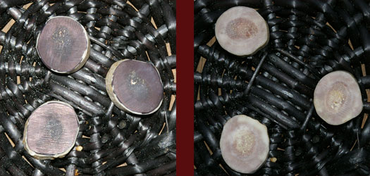

and the other two pieces have a star on one side and a moon on the other:

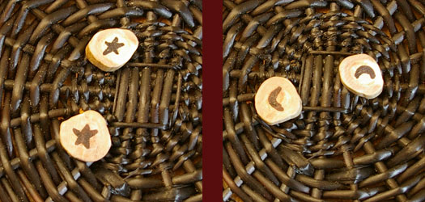

- All five game pieces are placed in a bowl and the players take turns gently flipping the bowl so that the pieces are all in the air and then land in the bowl. We found it easier to toss the pieces as you would toss dice.
- Scoring:
For a score to be recorded, all three marked-unmarked pieces must land the same way up (all marked or all unmarked). If these three pieces show a mixture of marked and unmarked sides then no score is recorded and the bowl passes to the next player. If all three marked-marked pieces land the same way up, then the other two pieces determine the score. If they match, two stars or two moons, then the player receives 2 points. If they are unmatched then the player receives 1 point. If a player scores then they play again. Before starting, the players should decide how long the game will last, possibly until one player reaches 11 points.

Examples:

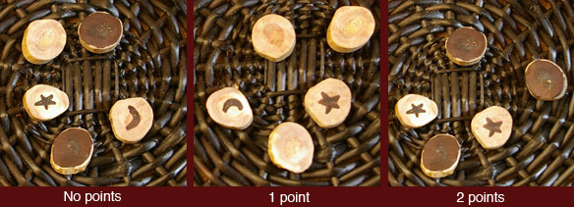

Activity/Lesson
Development
- Divide your class into groups of size 3 or 4. Have each group play the game and keep track using a tally sheet. When the game is completed have each group of students construct a bar graph from the data in the tally sheet. Have the students examine all the bar graphs and look for common attributes. Pose questions, which can be answered from the bar graph, for example: did the winning student have more than twice the number of points as the last place student?

Example Tally Sheet:

Round | Name | Name | Name | Name
 | Alison
1 | 1
2 | 0
3 | 1
4 | 2
5 | 0
6 | 0
7 | 0
8 | 1
9 | 1
10 | 0
11 | 0
12 | 0
13 | 1
14 | 0
15 | 1
16 | 0
17 | 2
18 | 0
19 | 0
20 | 0

Example Bar Graph:

